WEEK2:

SOWBARNIGAA SRIDHARAN

230701327

Create Table Emp_tab(Emp_no NUMBER(6), Emp_Name Varchar(20), Job VARCHAR(25), Basic NUMBER(10), DA NUMBER(10), HRA NUMBER(10), PF NUMBER(10), Gross NUMBER(10), Net NUMBER(10));

desc Emp_tbl;

select * from tab;

select * from Emp_tab;

select * from user_tab_comments;

Begin

Insert into Emp_tab (Emp_no, Emp_Name, Job, Basic, PF) values(1001, 'Shayaan', 'Accounts', 100000, 10000);

Insert into Emp_tab (Emp_no, Emp_Name, Job, Basic, PF) values(1002, 'Adhavan', 'Admin', 200000, 9000);

Insert into Emp_tab (Emp_no, Emp_Name, Job, Basic, PF) values(1003, 'Alia', 'HR', 150000, 8000);

Insert into Emp_tab (Emp_no, Emp_Name, Job, Basic, PF) values(1004, 'Abishek', 'Database', 125000, 7000);

Insert into Emp_tab (Emp_no, Emp_Name, Job, Basic, PF) values(1005, 'Bose', 'Security', 150000, 5000); end;

/

update Emp_tab set DA = 0.3*basic, HRA= 0.4*basic;

update Emp_tab set Gross=basic+DA+HRA+PF, Net = DA+HRA;

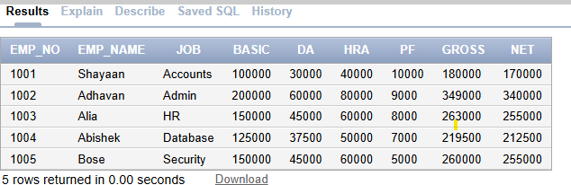

update Emp_tab set Gross=basic+DA+HRA+PF, Net = basic+DA+HRA;

select Emp_no, Emp_Name from Emp_tab where Net <200000;